**Acknowledgement**

First and foremost, we’d like to extend our sincere gratitude towards Mr. Rasika Alahakoon, our module lecturer. We are extremely humbled and grateful to have been able to receive his mentorship, guidance and support.

The overall accomplishment of this project demanded a significant amount of mentorship and guidance from many individuals. As a team, we are extremely fortunate to have had this from start to finish.

Finally, we wouldn’t have been able to successfully complete this assignment without the hard work and assistance of all the team colleagues itself. We all enjoyed working with each other.

**Abstract**

Title: An analysis on how Tesla utilizes Data Warehousing, Big Data, Data Mining, Knowledge Management and Business Intelligence.

Subject: PUSL3110

University: Group/ 19.2 SOC/ NSBM

Word Count:

This assignment presents our research and analysis on how Tesla has made use of Data Warehousing, Big Data, Data Mining, Knowledge Management and Business Intelligence to become the tech pioneer of the automotive industry.

**Introduction:**

In 2003, a couple of ambitious engineers wanted to boost the transition towards sustainable means of transport. They achieved this by introducing electric cars to the market. They helped deviate the market away from gasoline ridden cars towards electric vehicles. The sole intention behind Tesla is to advance the flow towards sustainable energy and transport so that the world stops depending on fossil fuels. Today, Tesla doesn’t only manufacture electric vehicles, but also an interminably extensible clean energy generation and storage commodities.

As of June 2021, the Tesla Model 3 has become the best-selling plug-in electric car, becoming the first electric car to sell 1 million units globally. With a market capitalization of $1.118 Trillion, this has officially placed Tesla at the worlds 6th most valuable company.

**Tesla and Data Warehousing**

Location of data warehouse that tesla uses. - Shikari

**How Tesla utilizes Big Data**

**What is Big Data?**

Big Data is a voluminous collection of data that grows at exponential speed and comes in a variety of formats. Since data is produced from a variety of sources, it could be so complex and unpredictable that it is challenging to connect and correlate it. Due to this, it cannot be processed, analyzed or stored with the utilization of traditional tools.

Companies and organizations like Tesla collect big data to utilize outside intelligence with the aim of enhancing operations, offer more improved customer service and engagement, polish advertising methods as well as improving marketing and promotion tactics.

It is undeniable that Tesla is pre-eminent in the electric vehicle game. This is mainly because of how deeply Tesla relies on big data, artificial intelligence and other aspects to outdo its competitors. Big Data plays a significant role in the company’s success. On a weekly basis, Tesla produces 2 to 5 terabytes of data on average. Tesla’s invaluable asset is the quantity of data gathered for data analysis.

Before Tesla initiated its automobile manufacturing venture, the most notable data collection tactic that it executed was the documentation of data that both consumers and cars generated in terms of product utilization. With that, they constructed a large database of customers who are interested in purchasing the latest drive technology.

**How Tesla utilizes Big Data in Autonomous Cars**

Tesla takes advantage Big Data to propel electric cars to greater heights. Autonomous vehicles (vehicles that possess self-driving capabilities) have the ability of sensing its surrounding environment and moving around with little to no human input. This entails autonomous vehicles to fully rely on data and information.

As of yet, Tesla has gathered 1.3 billion miles of data from autopilot accoutered cars that have been running all around the world in different weather circumstances. Tesla gathers all viable data analytics from their vehicle owners. Based on the data accumulated, Tesla is able to foresee and solve issues before they occur.

Cameras, radars, LIDAR and ultrasonic sensors that are installed in Tesla’s cars collect various aspects of information.

A variety of data, from the point of hazard occurrences on the road all the way to something as mere as the driver’s hand placement on the vehicle is all crowdsourced by Tesla.

The data culminated between the company cloud and car is gathered and observed. This also includes data such as weather data, real time traffic circumstance data, object mapping database (for the identification of light poles, trees, animals or humans, etc.), GPS data and data from other vehicles. Tesla’s vehicles are also equipped with sim (3G/4G) to wirelessly link vehicles to their corporate cloud for further evaluation.

From this data analysis, the driver’s actions and the car’s positions are combined and mapped. This enables Tesla’s primary autopilot data tracking system to determine the paths that the car takes.

Tesla also utilizes a fleet learning algorithm. When a vehicle observes something new from the newly updated dataset via a machine learning method, all the other connected vehicles would instantaneously learn it. A deep neural network algorithm is utilized to inculcate its autopilot with obtained real world data.

Not only has the collection of data aided the creation of Tesla’s famous autonomous vehicles but also in research and development, customer satisfaction, maintenance, vehicle performance and the improvement of Tesla’s future products. Data is also utilized from both positive and negative customer feedbacks to know where future improvements need to be made.

**Tesla and Cloud**

Every Tesla vehicle sends data to the cloud when they are not autopilot enabled.

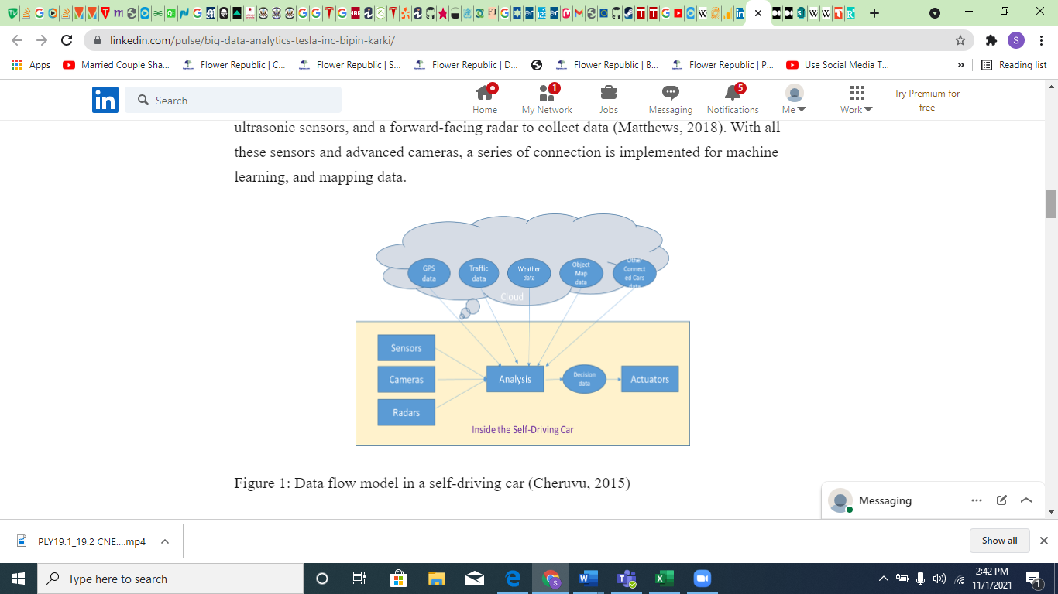

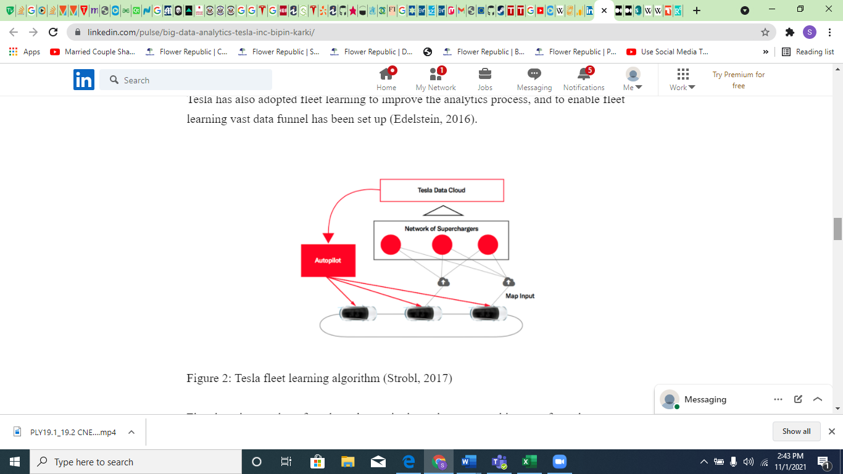

Bibliography -

<https://medium.com/xnewdata/tesla-big-data-success-case-6429af3cd58c>

<https://www.linkedin.com/pulse/big-data-analytics-tesla-inc-bipin-karki/>

<https://www.sas.com/en_us/insights/big-data/what-is-big-data.html>

<https://www.guru99.com/what-is-big-data.html>

<https://searchdatamanagement.techtarget.com/definition/big-data>

<https://bernardmarr.com/the-amazing-ways-tesla-is-using-artificial-intelligence-and-big-data/>

<https://www.bbntimes.com/science/how-tesla-is-using-big-data-benefits-challenges-of-big-data-in-self-driving-cars>

<https://bigdatanomics.org/index.php/connected-vehicles/261-tesla-s-autonomous-car-use-of-big-data>

<https://www.techiexpert.com/how-tesla-is-using-artificial-intelligence-and-big-data/>